Wisdom, Medicine, and the Soul

AAPC SOUTHEAST REGION
Annual Conference

October 20-22, 2017

Kanuga Conference Center
Hendersonville, North Carolina

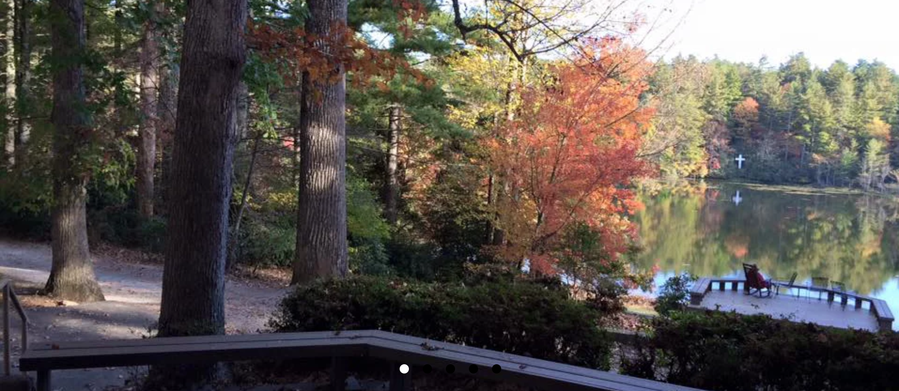

Learning, networking, and renewal in the mountains of Western North Carolina.

We extend a warm AAPC SE welcome to ALL mental health professionals, ministers, students, and others interested in the intersection of psychotherapy, spirituality, and theology. Attendees can earn 14.5 CE HOURS of NBCC-, AAMFT-, and ASWB-approved continuing education, including
2 Ethics credits.

See Below for Information about Conference Program,
Registration, & Lodging

Click Here to Register!

Plenary Gatherings

Accompanying Wayfarers: Mental Health, Theology, and Human Flourishing
Warren Kinghorn, MD, ThD

Modern mental health care is dominated by medical models of diagnosis and treatment, frequently structured by the diagnostic categories of the DSM. But as current debates like the relationship between moral injury and post-traumatic stress disorder (PTSD) make clear, the DSM is not only a clinical, but also a moral, document. It has a complicated political history, and its diagnoses, however useful, always emerge within particular social and political contexts. Healing practitioners must therefore supplement our use of the DSM with a broader vision of what it means to be human. For this conference, we will move beyond medical models and explore how theology and faith community practices can both set the DSM in its proper place and point the way to innovative paths to healing. We will engage the importance of stories and explore the Christian theologian Thomas Aquinas’ depiction of humans as wayfarers journeying to God – an image that bears practical fruit for everything from counseling to the use of psychiatric medication. Finally, we will engage the role of healing community and explore particular episodes within religious history in which people of faith have developed ideas and practices that remain fruitful and transformative for the care of people with mental health problems.

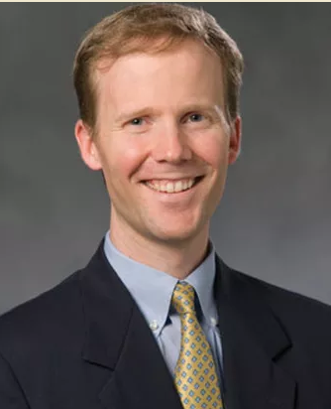
Warren Kinghorn is a theologian and psychiatrist whose work centers on the role of religious communities in caring for persons with mental health problems and on ways in which Christians engage practices of modern health care. Jointly appointed within Duke Divinity School and the Department of Psychiatry and Behavioral Sciences of Duke University Medical Center, he is a staff psychiatrist and clinical teacher at the Durham VA Medical Center. He is also co-director of the Theology, Medicine, and Culture Initiative.

Dr. Kinghorn will be speaking Friday October 20, 7 - 9 pm, and Saturday October 21, 9 am – 12 noon.

Click Here to See a Short Video of Dr. Kinghorn

Plenary Gatherings

Black Women and the Burden of Strength
Chanequa Walker-Barnes, PhD, MDiv

Black women are strong. At least that’s what everyone says and how they are constantly depicted. But what, exactly, does this strength entail? And what price do Black women pay for it? In her first plenary presentation, Dr. Chanequa Walker-Barnes examines how three core features of the StrongBlackWoman ideology — emotional strength, caregiving, and independence — constrain the lives of African American women and predispose them to physical and emotional health problems, including obesity, diabetes, hypertension, and anxiety. Drawing upon womanist pastoral theology and twelve-step philosophy, she calls upon pastoral caregivers to aid in the healing of African American women’s identities and crafts a twelve-step program for StrongBlackWomen in recovery.

In her second plenary address, Dr. Walker-Barnes will speak on themes from a book (in progress) on racial reconciliation.

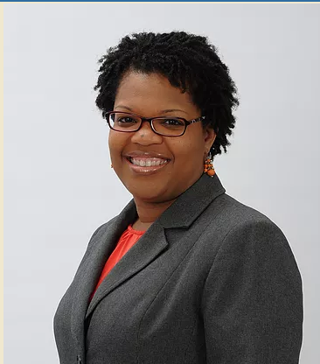
Chanequa Walker-Barnes is Associate Professor of Pastoral Care and Counseling in the McAfee School of Theology at Mercer University. She is a theologian and a licensed clinical psychologist whose mission is to serve as a catalyst for healing, justice, and reconciliation in the Christian church and beyond. Her first book, Too Heavy a Yoke: Black Women and the Burden of Strength explores the icon of the StrongBlackWoman and provides a framework for liberative pastoral care with African American women. She is currently at work on her second book, which addresses racial reconciliation.

Dr. Walker-Barnes will be speaking Saturday October 21, 1:30 – 4:30 pm.

Click Here to See a Short Video of Dr. Walker-Barnes

Click Here to Register for Conference

SCHEDULE OF WORKSHOPS

Friday (1:00-2:30)

- It’s About Time
- The Enneagram: Bridging Psychology and Spirituality
- Partnership for Pastoral Counseling: An Ongoing Story of Collegiality
- Conditions May Vary—Field Notes from the Trail
- Spiritual Trauma of Sexual Identity

Friday (2:45-4:45)

- AAPC Southeast Region: Supporting the Care of the Souls, Part 1

Saturday (7:00-8:30)

- AAPC Southeast Region: Supporting the Care of the Souls, Part 2

Sunday (9:00-10:30)

- Introduction to the New Certificate in Spiritually Integrated Practice
- Case Presentation: A Model for Group Consultation
- Relational Mutuality: A Kenotic Social Ethic for Handling Privilege
- Morality and the Evaluation of the Political Patient

WORKSHOP Descriptions and Presenters (ALPHABETICALLY)

Case Presentation
The workshop will be an opportunity to reflect theologically on a case presented by a student from Mercer University. The interest of this workshop is less on the clinical details and more on theological reflection with the therapist. Workshop participants will be invited to make connection to their own theological understanding.

Robert Cooke is a pastoral counselor at Triangle Pastoral Counseling, Raleigh, North Carolina. He is a Certified Fee Based Practicing Pastoral Counseling in North Carolina and a Fellow in AAPC.

Conditions May Vary
We are in a time of unprecedented change. Over the past 5 years, Dr. Harkins has served in leaderships at many levels. In this workshop, Dr. Harkins will draw upon “Field Notes” gathered especially over the years, drawing upon experience as a trail runner as a metaphor. Using a variety of modalities, we will discuss the challenges, and possible solutions of caring for clergy, consulting with churches and other institution, and responding to transitions in our own discipline during these challenging times. Drawing the clinical wisdom, theological insight, and theoretical resources of our discipline, and a few of his own mistakes, participants will consider how to use gifts and graces to expand practice modalities, consulting opportunities, and cultivate resilience and flourishing in those for whom we care, including ourselves.

William Harkins is Senior Lecturer of Pastoral Theology and Care; Co-Director of ThD Program at Columbia Seminary. Dr. Harkins is a licensed Marriage and Family therapist, an approved supervisor in AAMFT, and a Diplomat in AAPC. He serves as a psychological health faculty member for CREDO, a wellness program for ECUSA and PCUSA clergy. He is an ordained Episcopal priest, and serves as Canon Associate at the Cathedral of St. Philip.

The Enneagram
The Enneagram is a powerful guide to deeper connections with ourselves, with others, and with God. This ancient symbol offers a map for cultivating an authentic witnessing presence, as we seek not so much to know more, but to know with more of ourselves. As we practice working skillfully with our personality, recognizing its gifts and shadow, and loosening the grip of habit and identification, we can experience a deeper sense of presence and attention. Bring an open heart and curiosity about yourself and others, and let’s see what we can discover together.

Jeanine Siler Jones is a Licensed Clinical Social Worker in private practice in Asheville, NC, and an Enneagram teacher certified in the Narrative Tradition. She has studied with Cynthia Bourgeault in her Wisdom Schools and weaves contemplative practices into her work as therapist and teacher.
________________________________________________

Introduction to the New Certificate in Spiritually Integrated Psychotherapy
AAPC SE has developed a 30-hour continuing education certificate program in spiritually-integrated psychotherapy. The program explores the ways spirituality, religion, and the search for meaning influence the lives of clients and psychotherapists. Understanding their influence can enrich the efforts of both client and therapist in the work of psychotherapy. This workshop provides an orientation to the program and its curriculum for potential participants and potential instructors.

John Eddinger is a certified Pastoral Counselor and a certified Trauma Professional. He was a founding member of the Grady Hospital post-partum support group for mothers who suffer intrauterine fetal deaths. He has experience working with people who suffer chronic pain, stroke victims, and paraplegics. He works with individuals, couples, and families. His practice is primarily with adults and adolescents dealing with depression, anxiety, addictions and compulsive behaviors, loss, self-esteem, divorce and remarriage, and step-family issues. In addition, he has over 4000 hours of experience leading groups for chemically dependent people.

Bill Harkins is Senior Lecturer of Pastoral Theology and Care; Co-Director of ThD Program at Columbia Seminary. Dr. Harkins is a licensed Marriage and Family therapist, an approved supervisor in AAMFT, and a Diplomat in AAPC. He serves as a psychological health faculty member for CREDO, a wellness program for ECUSA and PCUSA clergy. He is an ordained Episcopal priest, and serves as Canon Associate at the Cathedral of St. Philip.
David Harris is the co-founder for Rock Springs Counseling and Executive Director of Professional Coach for Work, Life, and Relationships. He is an active participant in the therapeutic community, speaking frequently at local and state meetings and conferences on topics ranging from career transitions to new trends and developments in psychotherapy.
​Russell Siler Jones is a Diplomate in AAPC, a North Carolina Certified Fee-Based Practicing Pastoral Counselor, and North Carolina Licensed Professional Counselor Supervisor. He is Director of CareNet/Wake Forest Baptist Medical Center’s Residency in Psychotherapy and Spirituality.
_________________________________________________

It’s About Time
This workshop stimulates continuing reflections on the phenomenon of time and the linguistic process of story. Joan Didion writes, "We tell ourselves stories in order to live." I submit that good storytelling manifests a destination, a path, a direction, and that storytellers inevitably deal with problems and barriers in negotiating the course of life. Thus, we clinicians early on ask the counselee where they want to go or what is their goal? It is here we create therapeutic space and participate in a stewardship of time to test the possibilities of the counselee realizing the desired destination. Some stories are worth living and the clinician may be called to imaginatively demonstrate stories, with associated memories, feelings, and choices, which make possible the counselee's goal. Alternatively, to participate in creating "negative postdiction," the opposite of "positive prediction," probably destins us to failure in the therapeutic endeavor. Clinical examples will be used and solicited in our stewardships of time and story.

Jim Coffman has over thirty years of practice as a Marriage and Family Therapist. He has significant experience in training and supervising Pastoral Counselors in Tennessee. He is also a writer and teacher and has held many leadership roles in this profession.

___________________________________________

Morality and the Evaluation of the Political Patient
Political life is a system that may analogize what we know about family life. That understanding can open our minds to insights about the ways our patients think and process ideas. Political views are attempts to solve problems. Obsessive expressions of views are also an effort to solve a problem, especially in the context of family relations. This workshop will delve into the meaning of different expressions, and how our own understanding can guide the family toward its real goals of avoiding disintegration. We will look at how our own resistance manifests itself, and discuss ways to turn our own resistance into ways of positively joining with those in our care.

William Scar practices Pastoral Psychotherapy and Supervision in Aiken SC. He is a Diplomate with AAPC, and has offered supervision and consultation in the field of Pastoral Psychotherapy. For more than twenty years, he has provided leadership to the counseling centers in Los Angeles and Cincinnati

Partnership for Pastoral Counseling: An Ongoing Story of Collegiality
For 20 Years, the Partnership for Pastoral Counseling has served churches and the community of Western North Carolina as a funding subsidy for clients who could not afford faith-based counseling. The organization has subsidized over 20,000 hours of counseling with almost $1 million supporting 12 pastoral counseling providers in Asheville, NC and the surrounding counties. The story will be told by the Founder, the Executive Director, and a Provider/Board Member. We will present its history, working documents, challenges and successes, and how it might work in another community.

Michael Hester is the founding director of the Pastoral Counseling and Growth Center in Asheville, NC. He is also the founder and a member of the board of directors for Partnership for Pastoral Counseling. He is a Diplomate in AAPC and has served in various pastoral and academic positions.

Rebecca Wells is Executive Director for the Partnership for Pastoral Counseling, where she has served for eight years. She has also provided leadership among many other non-profits in the Western North Carolina area.

____________________________________________________

Relational Mutuality: A Kenotic Social Ethic for Handling Privilege
This workshop places a feminist theology of kenosis in dialogue with relational intersubjectivity and postcolonial social ethics to propose an approach to pastoral care and psychotherapy that addresses the potentially adverse effects of intersectional privileges on minoritized clients. Feminist kenosis offers a “power-for” approach to self-emptying that corrects for monovalent applications of kenotic ethics, which ironically privilege patriarchal, middle-class, white values and reinforce the social status quo, which is often problematic. Intersubjectivity situates this kenosis within its irreducibly relational context. And postcolonial social ethics highlights the intersectional effects of disparities in various social privileges within the caring relationship. Together, these components foster an approach to the practice of healing relationships that accounts for often neglected factors and thus promotes human, communal flourishing.

Matthew Beal is a Licensed Professional Counselor specializing in North Carolina. He is a Fellow with the American Association of Pastoral Counselors. He will be completing his Doctor of Philosophy in 2020.

___________________________________________

Spiritual Trauma of Sexual Identity
Sexual identity is continuing to be further nuanced and developed in both the academic and the psychotherapeutic arenas. Both therapists and clients are becoming increasingly competent at being aware of and addressing the dimensions of orientation, preference, intensity, plurality, and expression both within and outside of the cultural norms of gender and sexual identity. Additionally, the discussion around the spiritual aspects of trauma have increasing evidence both anecdotally and in the empirical literature. This workshop will assist participants in their understanding of both developing subfields as well as their potent intersection. Clinical best practices and exercises will be discussed and practiced with the participants. While the presenters will assume some basic knowledge on these various topics, there will be ample time in the workshop devoted to participant discussion and questions.

Portia Smith is an Assistant Professor at Pfieffer University where she teaches classes in Marriage and Family Therapy. She continues to practice therapy as well as offering supervision.

Daniel Stillwell is also an Assistant Professor at Pfieffer where he teaches in the MFT field. He has written for many professional research publications in the field of Marriage and Family Therapy.

_____________________________________

Supporting the Care of Souls
The American Association of Pastoral Counselors is in transition from a nationally-led to a regionally-led professional association. The Southeast Region continues to clarify its vision and mission, as well as provide opportunities for professional development and collegial support. This workshop gives attention to the vision and mission of AAPCSE and to the identity of pastorals counselors in this new landscape. All are welcome at this workshop, though it will perhaps be of more interest to members of AAPC than to our guests.

Russell Siler Jones is a Diplomate in AAPC, a North Carolina Certified Fee-Based Practicing Pastoral Counselor, and North Carolina Licensed Professional Counselor Supervisor. He is Director of CareNet/Wake Forest Baptist Medical Center’s Residency in Psychotherapy and Spirituality.

Kathryn Summers is in private practice in Durham, North Carolina. She has a certificate from the Carolina Institute for Clinical Pastoral Training and is certified by the state of North Carolina as a Fee-Based Practicing Pastoral Counselor. She is Chair-Elect for the Southeast Region and is the Vice-Chair for the North Carolina Association of Pastoral Counselors.

Click Here to Register

Or go to www.aapcse.org

Complete Conference Schedule
Friday, October 20, 2017
10:30 Registration begins
Noon Lunch
1:00-2:30 Workshops
2:45 – 4:45 AAPC Southeast Region: Supporting the Care of Souls , Part 1

5:00-6:00 Reception

6:00 Dinner

7:00-9:00 Opening Plenary: Dr. Warren Kinghorn

9:15 Reception for Newcomers and Students

Saturday, October 21, 2017

8:00 Breakfast

9:00-Noon Plenary: Dr. Warren Kinghorn

Noon Lunch

1:30- 4:30 Plenary: Dr. Chanequa Walker-Barnes

4:30-6:00 Self Care

6:00 Dinner

7:00-8:30 AAPC Southeast Region: Supporting the Care of Souls, Part 2

8:45: Toasts and Jam (Open Mic Talent Show) -- Fireplace Room

Sunday, October 22, 2017

8:00 Breakfast

9:00 -10:30 Workshops

10:45 -11:45 Worship -- Chapel

Noon Lunch

Conference Fees
(not including accommodations)
$140 for AAPC members (25% discount)
$180 for non-members
$95: Retirees
$50: full-time student (will be asked to help with some conference work)
One day pass: $95
Need continuing education credit? $30

Need a Scholarship?
If you are a full-time student, unemployed, or can provide some reason for financial need, you are encouraged to apply for a scholarship! All decisions will be made by the program committee. Please send an email with your request to JoEllen Holmes, program chair, at jholmeslcsw@gmail.com. We will ask that you volunteer with the program committee during the weekend. Examples of volunteer activities include helping at registration, assisting the speakers, or planning worship.

Click Here to Register

Or go to www.aapcse.org

